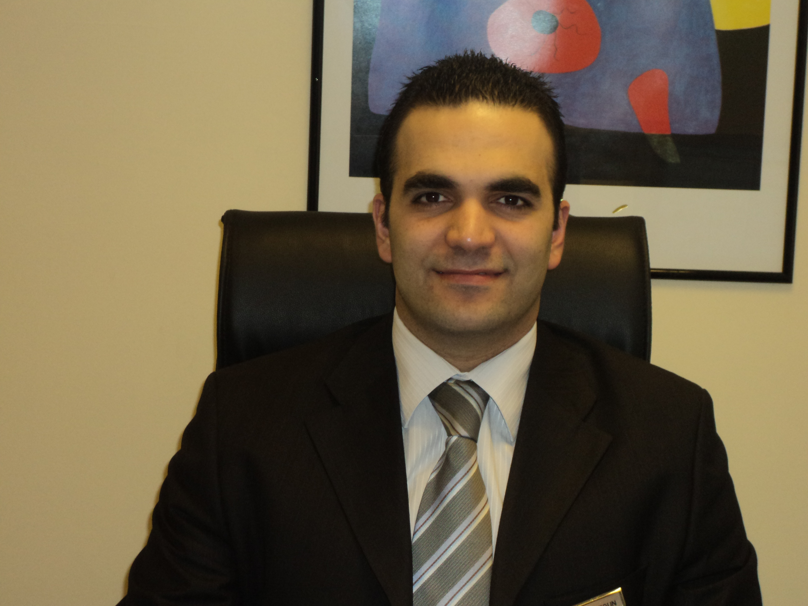
Rami Kastoun

Born on the 18th of October 1978 Lebanon - Koubayat
Lebanese Number: 009613961465
E-mail: kastounrami@gmail.com
Marital Status: Married

OBJECTIVE

My aim is to broaden my scopes of productivity over and beyond the present experience to a more dynamic and specialized establishment where my managerial skills as well as my technical competences can best be utilized. My wish is to contribute in the development of your hotel and in return to provide me with the career path I am looking for.

PROFESSIONAL EXPERIENCE

June 2015 till now Byblos Sur Mer***** (Lebanon)
Food & Beverage Manager
Operating outlet:

Al Azrak Oriental Restaurant // Al Marsa International Restaurant
Turnesol International Restaurant // Masa Fusion Restaurant
Piano Bar

In Charge of the daily operations of all points of sales inclusive of banquets
In Charge of the cost control department
In Charge of coordinating, managing and evaluating the service and the production team as well.
In charge of all menu compositions and products Development
In charge of all financial aspects of the department in terms of budgeting, direct and indirect cost monitoring, Profit & Loss statement.

June 2013 till June 2015 Alazzam Group (Bahrain)
Operation Manager
Operating Outlet:

Fauchon (1 Restaurant)
Pastarito (2 Restaurant)
Med Café (3 Restaurants)
Rice Bowl (2 Restaurant)

In Charge of restaurants and report direct to the owner
Preopening & Opening new restaurants
In Charge of the daily operations of all points of sales
In Charge of coordinating, managing and evaluating the service and the Kitchen Team as well
In charge of all menu compositions and products development
In charge of all financial aspects of the department in terms of budgeting, direct and indirect cost monitoring, Profit & Loss
In Charge of Maintenance team

September 2012 till May 2013 Palma Hospitality group (Qatar)
Director of Food & Beverage
Operating Outlet:

Damasca One Restaurant 500 Seat // Oriental Peal Restaurant 1,100 Seat //Damasca Two Restaurant 600 Seat …

In charge of 3 outlet Manager, 3 Chef and more than 200 employees
Preparing Damasca Restaurant to be franchise
Preopening & Opening the new restaurants
In Charge of the daily operations of all points of sales
In Charge of coordinating, managing and evaluating the service and the Kitchen Team as well
In charge of all menu compositions and products development
In charge of all financial aspects of the department in terms of budgeting, direct and indirect cost monitoring, Profit & Loss
In Charge of Maintenance team

March 2010 till August 2012 Le Commodore Hotel***** (Lebanon)
(Boubess Group)
Food & Beverage Manager
Operating Outlet:

Benihana Asian Restaurant // Cucina Italian Restaurant //
Lobby Bar // La Brassery International Restaurant // la Casbah Night Club // Banquet Operation for 600 Persons

In charge of 5 outlet Manager, 5 Chef and more than 150 employees
In Charge of the daily operations of all points of sales inclusive of banquets
In Charge of coordinating, managing and evaluating the service and the Kitchen Team as well
In charge of all menu compositions and products development
In charge of all financial aspects of the department in terms of budgeting, direct and indirect cost monitoring, Profit & Loss.

Since July 2007- March 2010: Grand Hills Hotel & Spa ***** (Lebanon)
Food & Beverage Manager
Operating outlets:

Pasquale Italian restaurant // Pool Café International Restaurant
Al Fayez Oriental Restaurant // Chez Alain French Restaurant
Bar One Fusion cuisine lounge bar // Apnea Night Club
Piano Bar // Banquet operations for 1.500 Persons

In Charge of the daily operations of all points of sales inclusive of banquets
In Charge of the cost control department
In Charge of coordinating, managing and evaluating the service and the production team as well.
In charge of all menu compositions and products Development
In charge of all financial aspects of the department in terms of budgeting, direct and indirect cost monitoring, Profit & Loss statement.

November 2006 – July 2007: Grand Hills Hotel & Spa ***** (Lebanon)
Asst. F&B Manager

In charge of Banquet Operation & Assisting the F&B Manager in his duties

July 2005 – November 2006: Grand Hills Hotel & Spa ***** (Lebanon)
Banquet Operation Manager

In charge of an assistant manager and seven banquet supervisors
Venues in charge of:
- The patio: 500 persons seated
- The Ballroom: 300 persons seated
- Pool Deck: 300 persons seated
- Al Fayez: 300 persons seated

December 2002 - July 2005: Phoenicia Inter-Continental ***** (Lebanon)
Wok W.o.k Asian restaurant 120 seats
Head Waiter
In charge of eight captains, eight waiters and two bartenders

February 2000 - December 2002: Phoenicia Inter-Continental ***** (Lebanon)
Pre-opening team
Mosaic Restaurant & E.D. Stone Night Club
Captain waiter

June 1998 – February 2000: Idarat Group (Lebanon)
Coco Loco restaurant 110 seats
Captain Bartender

June 1997 – June 1998: Idarat Group (Lebanon)
Le Retro restaurant 130 seats
Help Bartender

TRAINING

Pre-open team @ Intercontinental Phoenicia
Pre- open team @ The Small Ville Hotel
Hygiene and Sanitation
HACCP Certificate
Train De trainer
Guest Courtesy Technique
Customers come first
Customer Service
Telephone technique
Service leadership
Sweet training (up selling)
Quality guest service
CTC Training (Craft Training Certificate)
Health safety Training
Security training (fire training, bomb threat, crises incidents)
Guest Courtesy Training

Teaching Experience

2008 – Till 2012: AL KAFAAT TECHNICAL SCHOOL
Professor: - Selling and service principles in F&B operations
- Food & Beverage Cost control
- Bar Knowledge

EDUCATION

1998 – 2001: AL KAFAAT TECHNICAL SCHOOL – AIN SAADÉ
Superior Technical diploma in Hotel & Restaurant management

1995 – 1998: AL KAFAAT TECHNICAL SCHOOL – AIN SAADÉ
Technical Baccalaureate

COMPUTER SKILLS

Microsoft Office (Word, Excel, Power Point, Adobe…)
Micros, Omega, Fidelio & Opera (Sales & Catering)

LANGUAGES

English: Spoken, read and written fluently
French: Spoken, read and written fluently
Arabic: Mother tongue

REFERENCES

Upon Request

